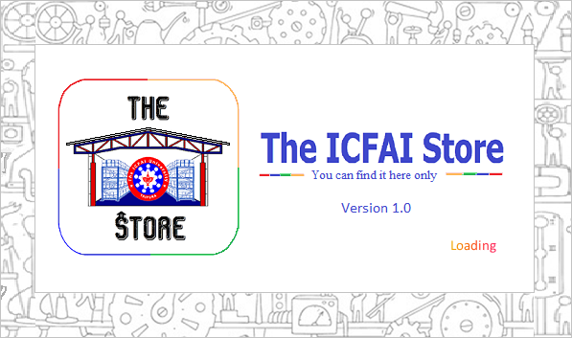

**About**

The ICFAI Store is a database application that can be used to keep records of presently stocked items, purchased items and issued items for any type of organizations, firms, industries and stores alike. These records can help any firm to better manage their products for transactional purposes.

**Software contents and How to use**

1. Loading Screen

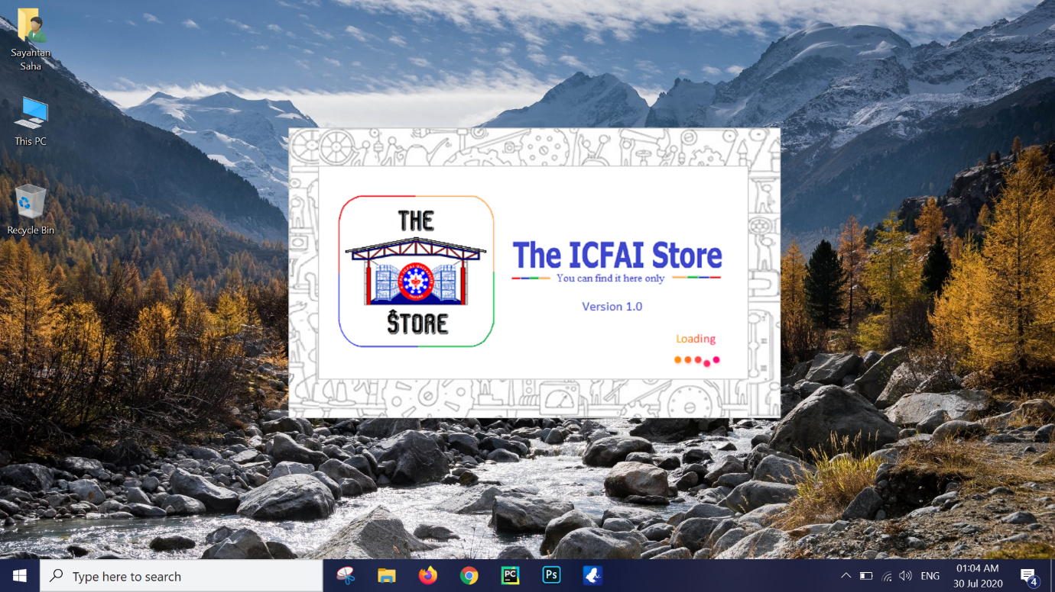

1. Intro Inactive Screen

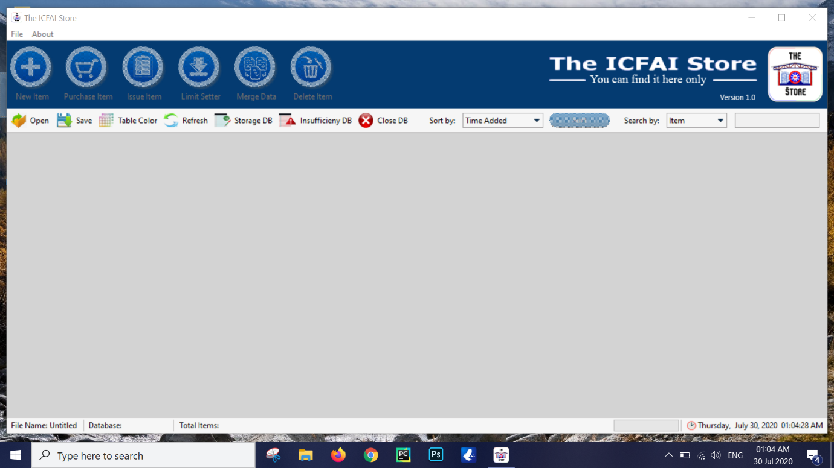

Points to observe

* Inactive Data-fill buttons
* Inactive Sort button
* Inactive Search field
* Untitled file name
* Blank/Unselected Database
* Blank Total Items value

The inactive Data-fill buttons, sort button and search field, prevents manipulation of any data in the database. It’s the interface screen that acts like a pause for the database table and hides the actual database when and wherever needed.

At first, in order to view the database, select either Storage DB or the Insufficiency DB according to requirement.

1. Database DB

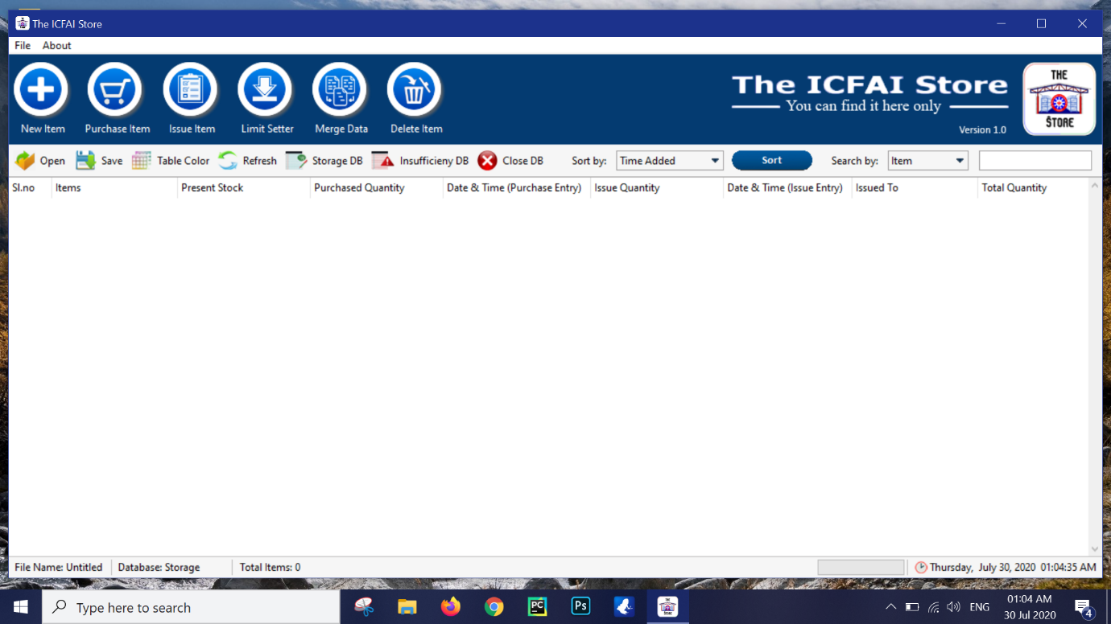

Points to observe

* Active Data-fill buttons
* Active Sort button
* Active Search field
* Storage Database selected
* Total Items value active
* Storage Database with columns Sl. No, Items, Present Stock, Purchased Quantity, Date & Time (Purchase Entry), Issue Quantity, Date & Time (Issue Entry), Issued To, Total Quantity

The Storage Database shows the data according to the above-mentioned columns. By using the Data-fill buttons and their respective entry windows any data/record in the Storage can be manipulated.

1. Insufficiency DB

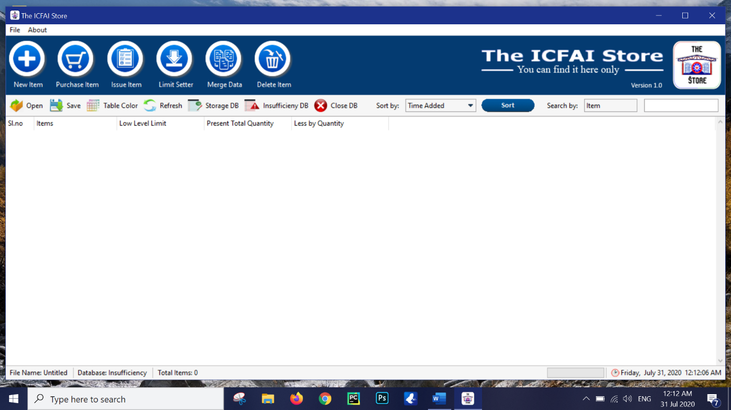

Points to observe

* Insufficiency Database selected
* Insufficiency Database with columns Sl. No, Items, Low Level Limit, Present Total Quantity, Less by Quantity

The Insufficiency Database shows the data according to the above-mentioned columns. By using the Data-fill buttons and their respective entry windows any data/record in the Storage can be manipulated.

1. New Item

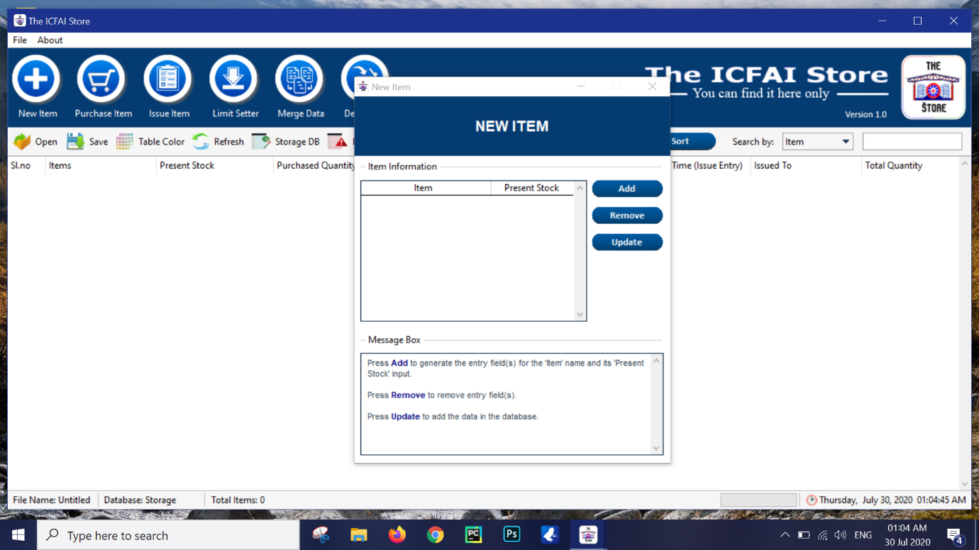

Pressing the New Item button will open the New Item window.

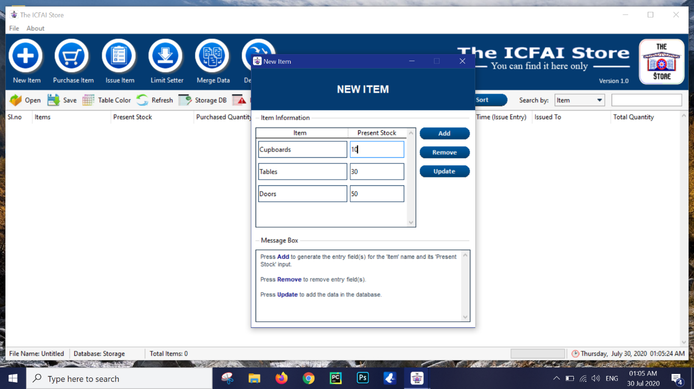

Press the Add button to add the entry columns and remove button to remove the entry columns.

Press the Update button to update the values in the Storage database.

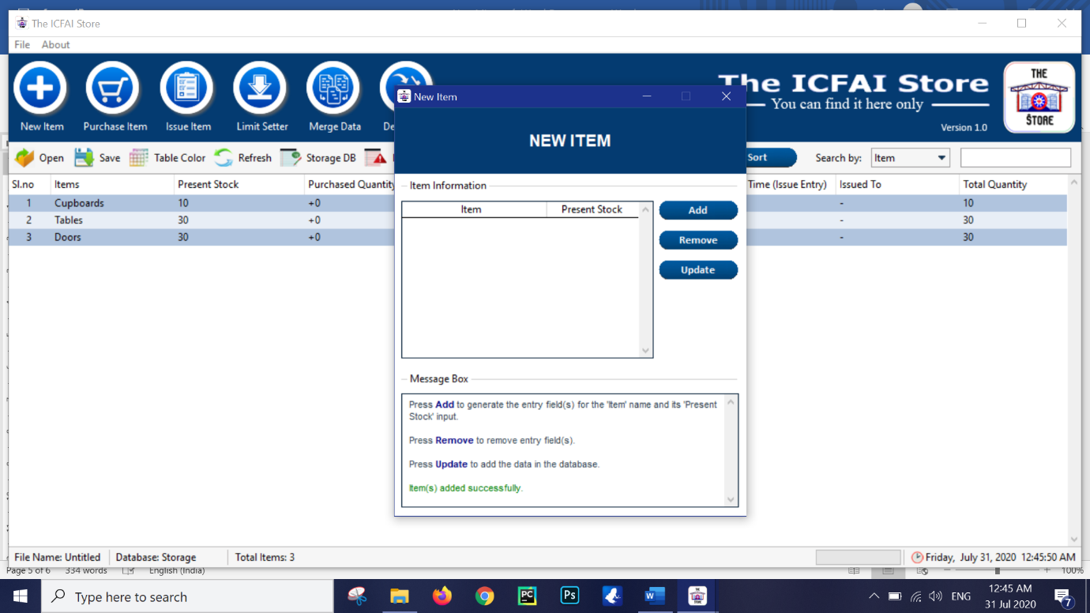

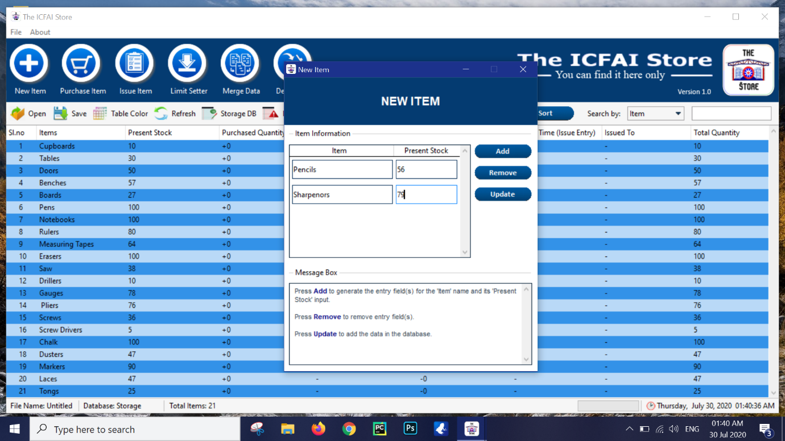

Points to observe

* Message box will show instructions and give update about any successful feats as well as errors made.
* Total Items value got updated with the amount of data in the table.

1. Purchase Item

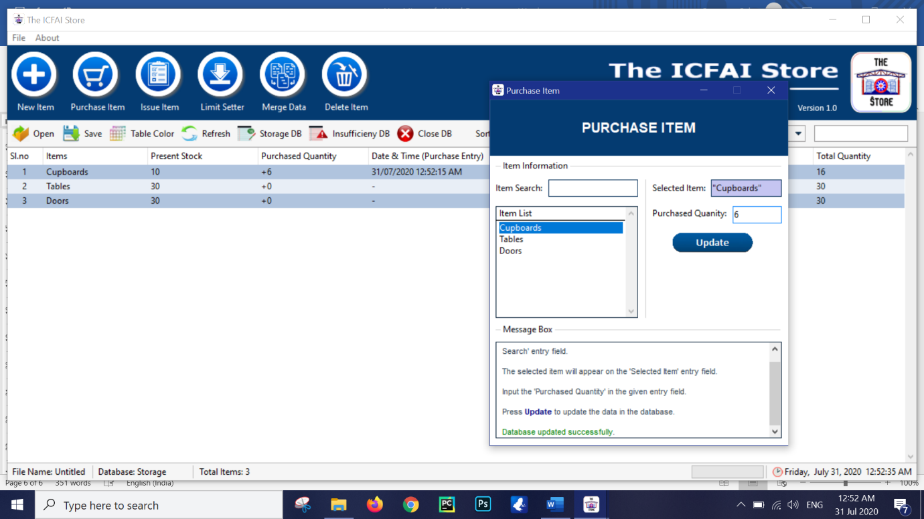

Press the Purchase Item button to open the purchase item window.

Select the required item by either searching in the item search or by manual search selection. The selected item will be updated accordingly in the database.

Points to observe

* Purchase Quantity data updates in the database along with the time of the entry of that data.
* The selected item is highlighted on the left.

1. Issue Item

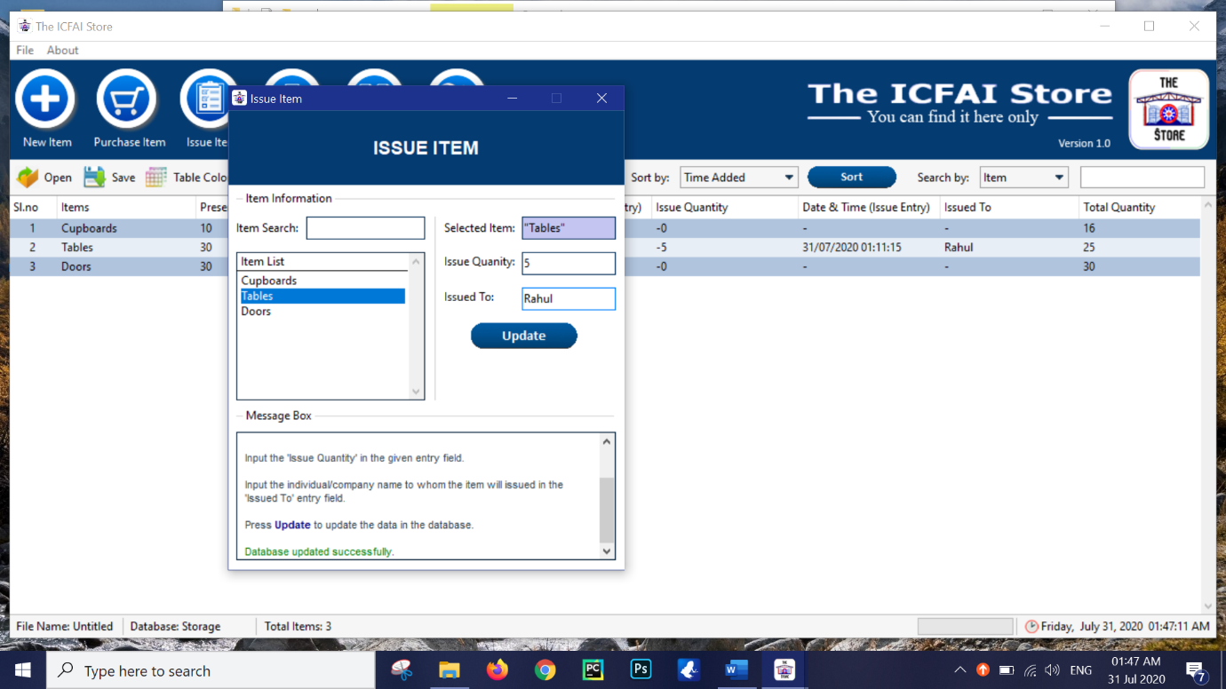

Process same as purchase process with an addition of Issued To entry field and different result.

Both Purchase quantity and issue quantity influences the Total Quantity .

1. Merge data

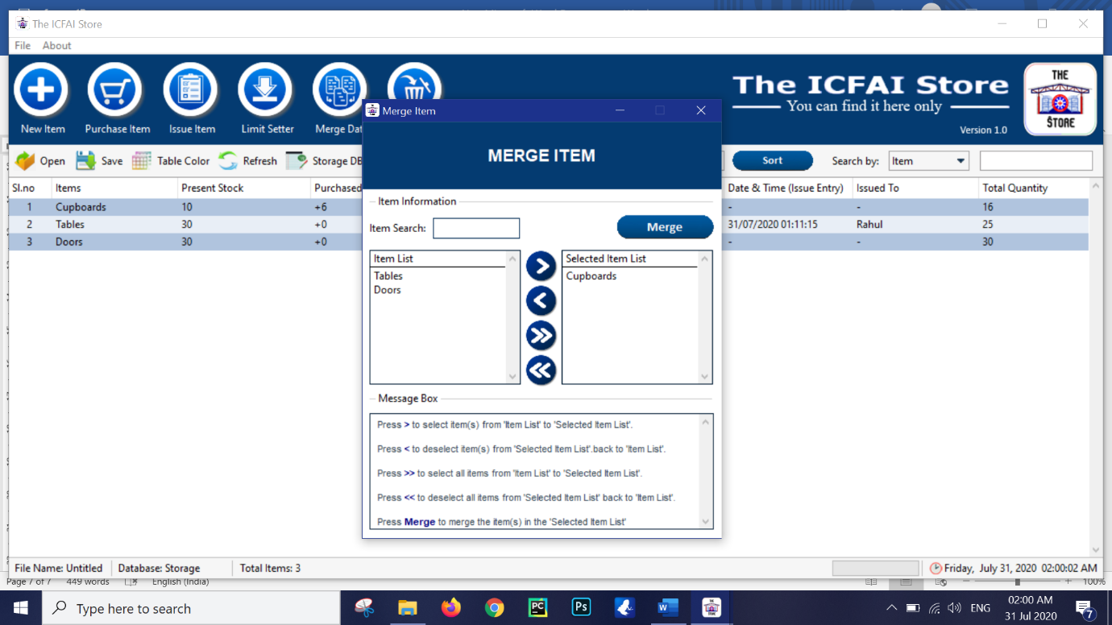

Point to observe

* >, <, >>, << buttons are designed in order to transfer the items from the item list to selected list for the merging process. Multiple items can also be selected at a time.

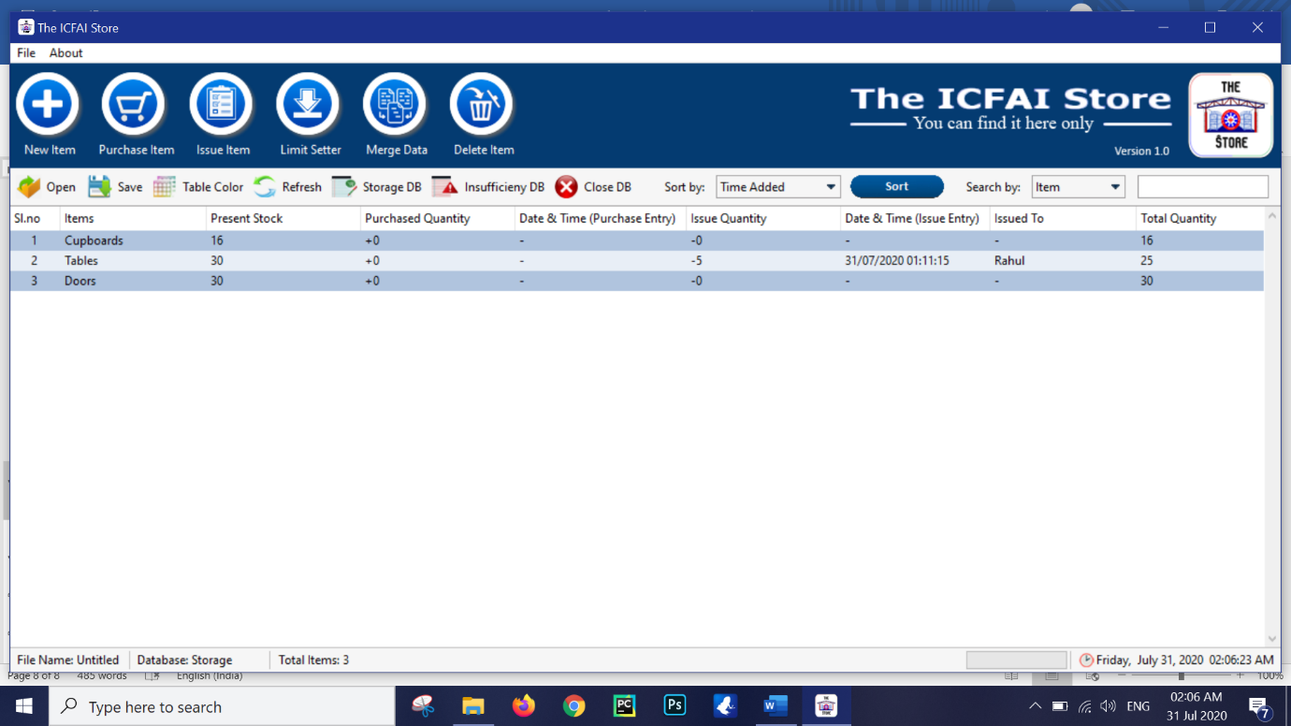

In case of merge. All the purchase and issue data will be removed and the total quantity that remains after adding the present stock with purchase and subtracting issue will merge with present stock giving the new updated value.

1. Delete item

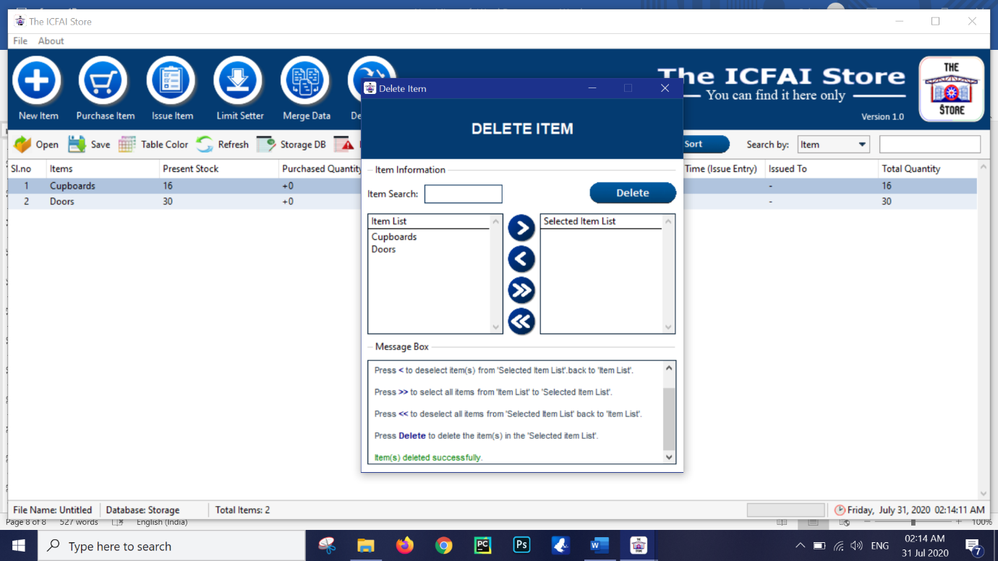

Process same as merge with the exception of deleting the selected data from both databases.

1. Limit Setter

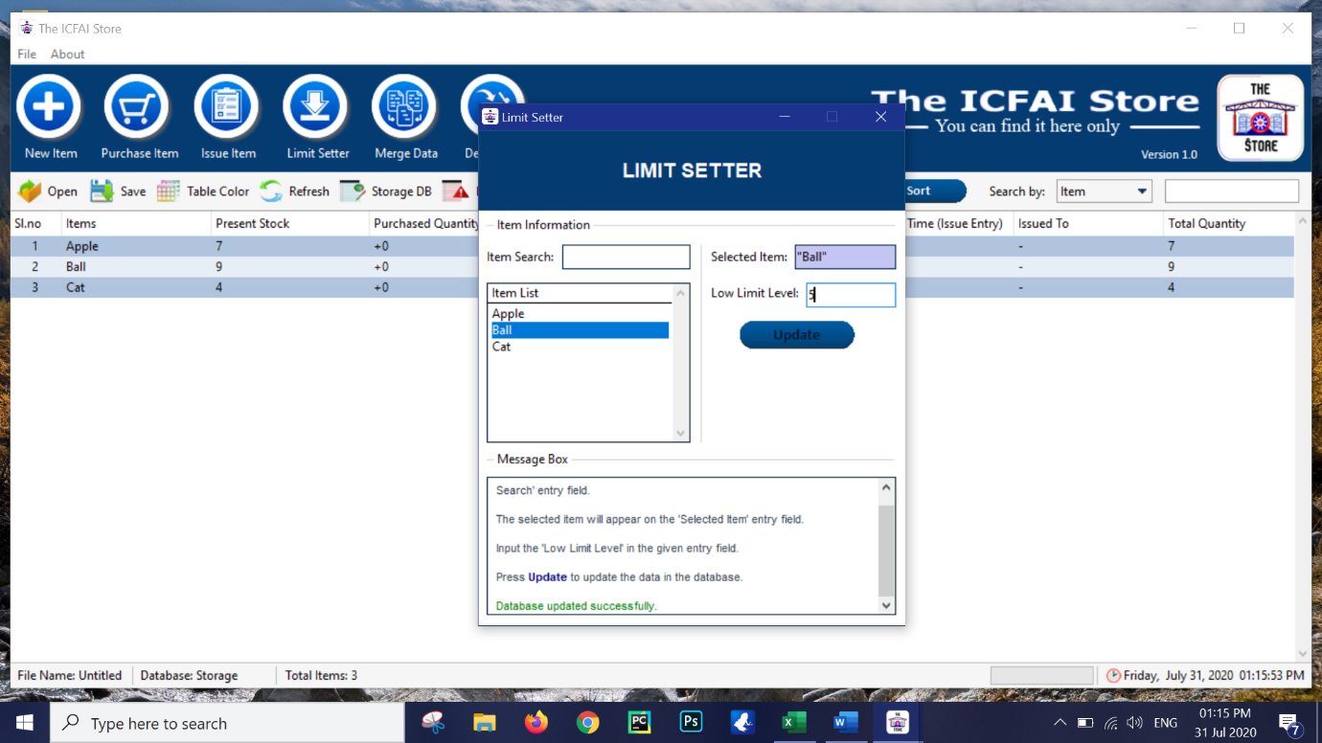

The limit setter sets a lower limit value for any item. Its value wont be reflected on the Storage database until the Total quantity of the concerned item goes lower than the limiting value, for which that particular row will turn into red in colour indicating the shortage of that item below the limiting level.

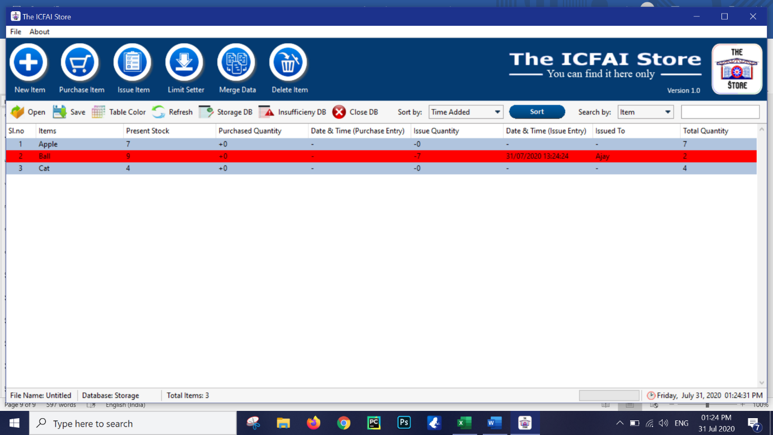

Once reddened, the limiting value along with other information can then be viewed in the insufficiency database. If a limiting value is not set then that item will not be reflected in the insufficiency database.

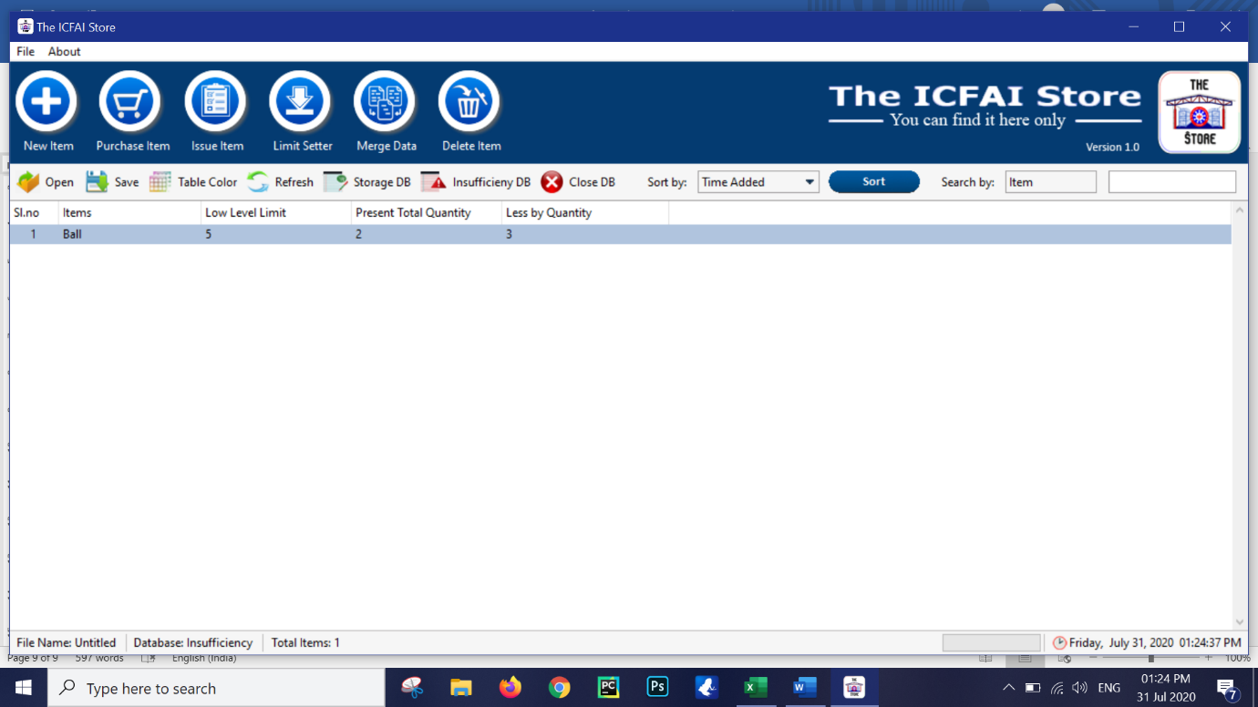

The insufficiency table will have records of all those items that will have total quantity less that of low limit level. It will also show the amount by which it is less than the required amount.

Note – If an item has its total quantity at 0. Then this item will also be reddened in the storage database and reflected in the insufficiency database irrespective of having ever set a limiting value.

Once the value exceeds above the requirement. The Storage database row for that item will be normal again and it will be removed automatically from the insufficiency database.

1. Sorting

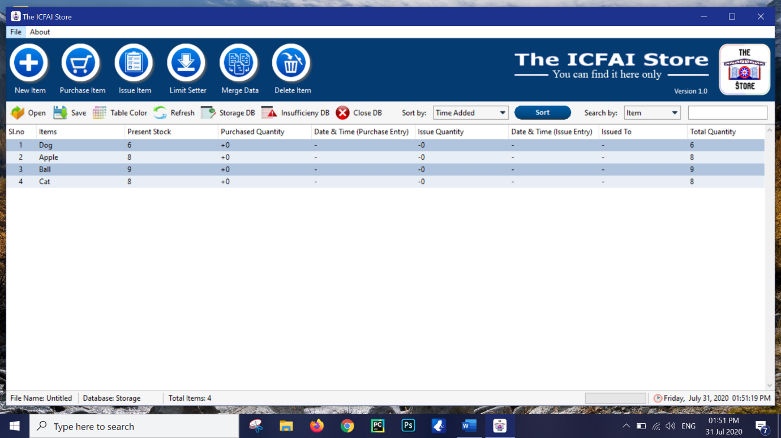

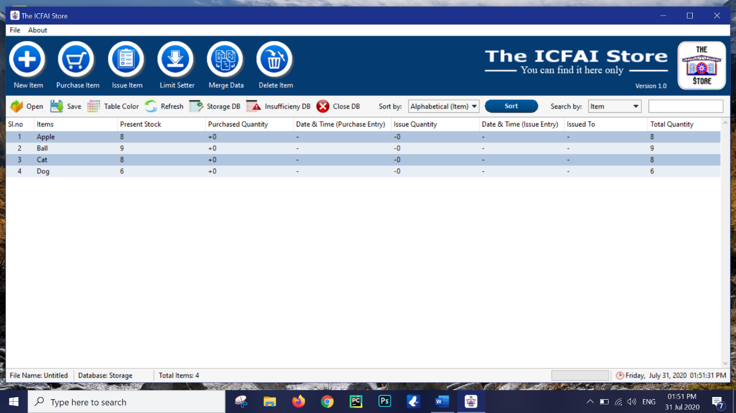

Point to observe

* The sorting style can be changed from the drop down menu.

With the help of the sort button in both tables data can be sorted with respect to the style that has been selected

1. Searching

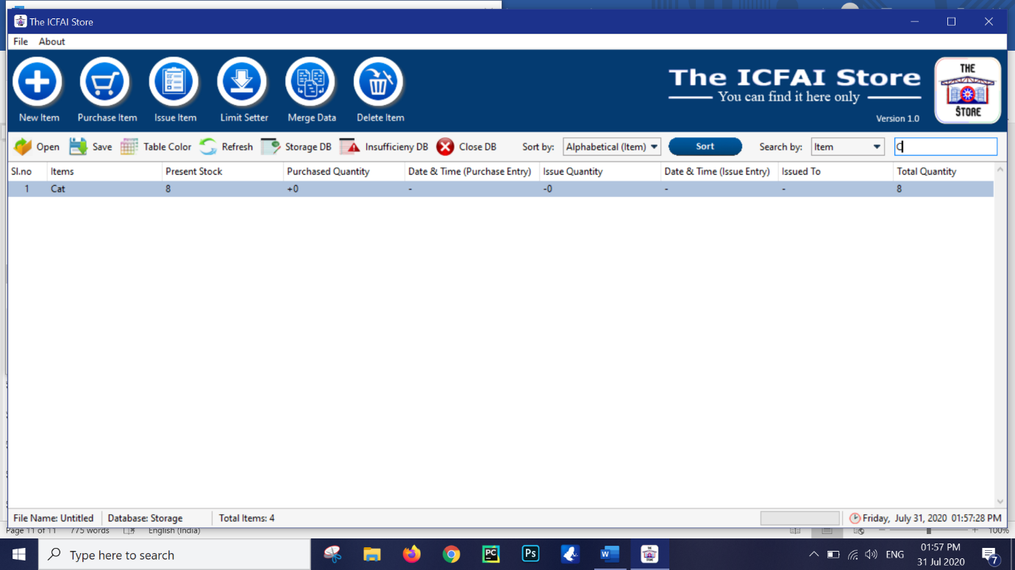

The searching process is same throughout the software where the database will get shortened dynamically with each character that matches with each character of the item name in the database.

However in case of Storage database, the style of the item search can be changed with the drop down menu and it will search by matching characters accordingly.

Once the characters are removed from the search entry box. The database will keep on expanding until it reaches its original length.

1. Refresh button

The refresh button will simply refresh the database

1. Table Colour button

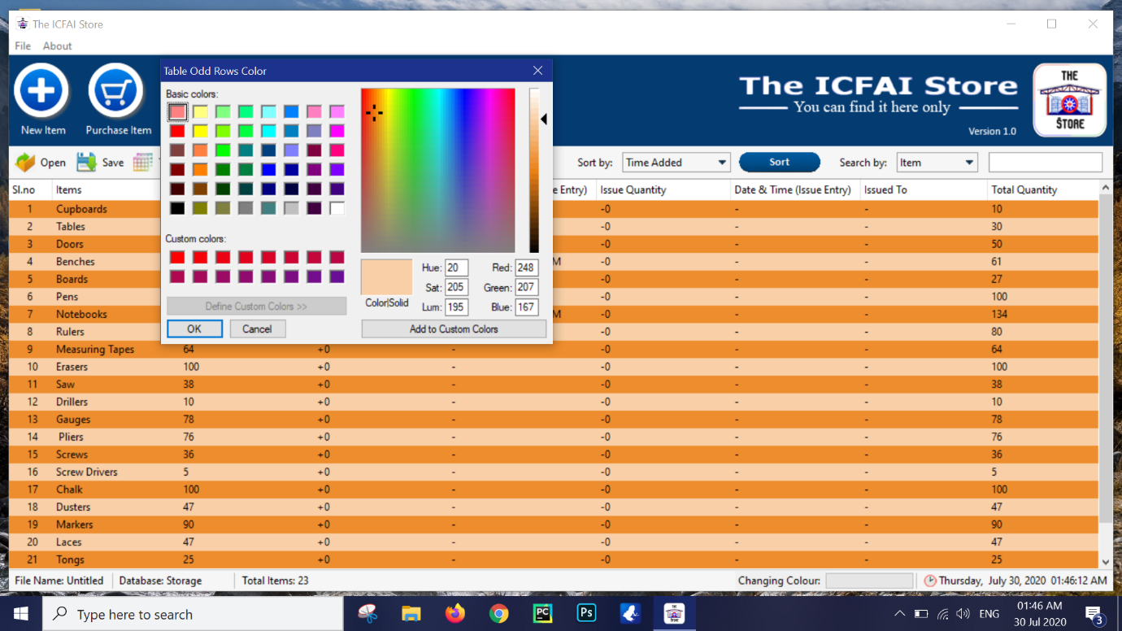

The colour for each odd and even row of the table can be changed with the help of this button. In order to keep the colour unchanged just close the dialog box or press cancel. As this dialogue will appear 2 times, check for the title of the dialogue box to know which rows will change its colour.

1. Save button

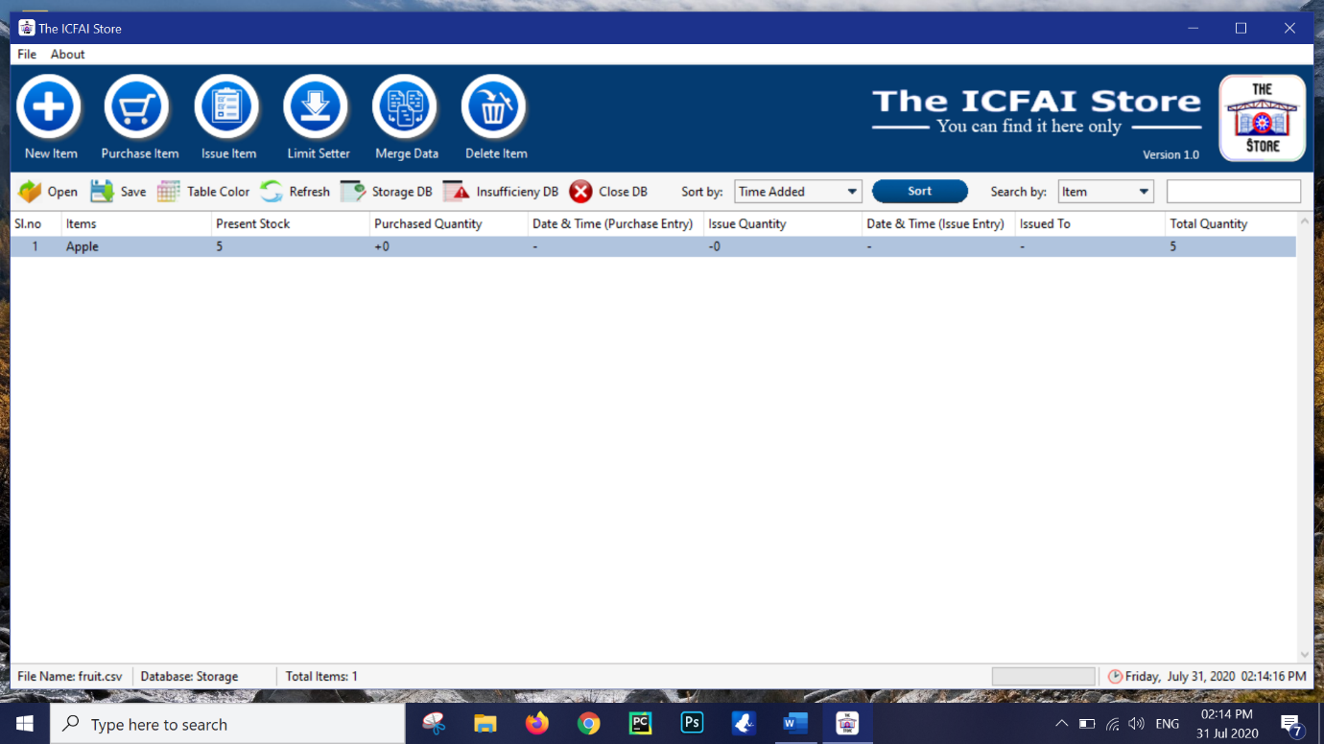

Once saved the file name will be reflected at the bottom and so will in case of load.

1. Close DB button

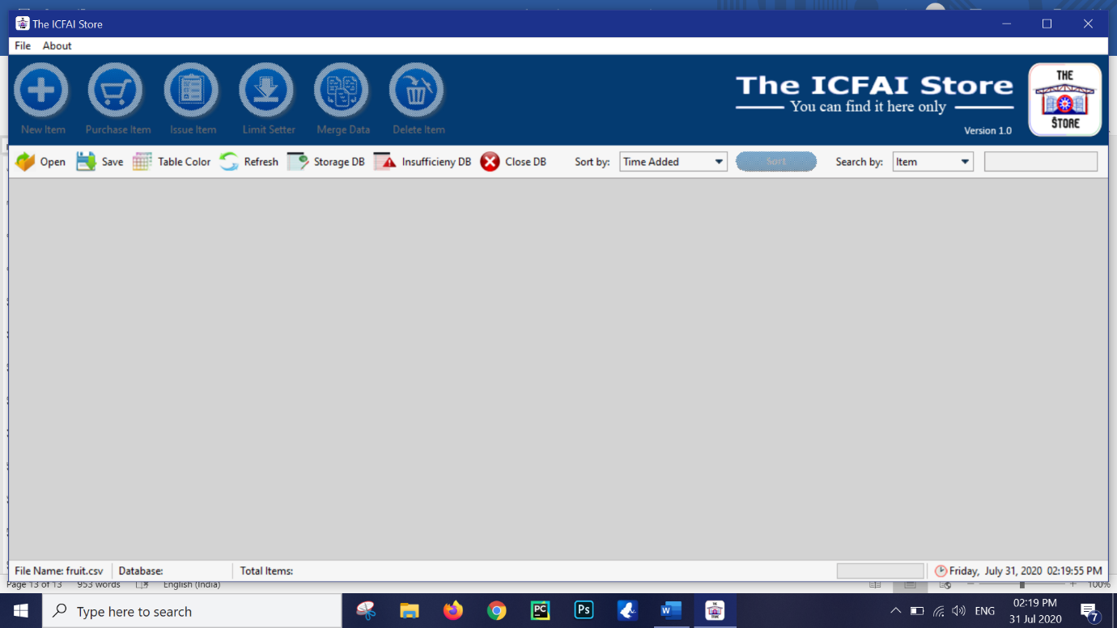

By pressing the close db button the screen can return back to the inactive state with exception of file name if saved.

1. New Database

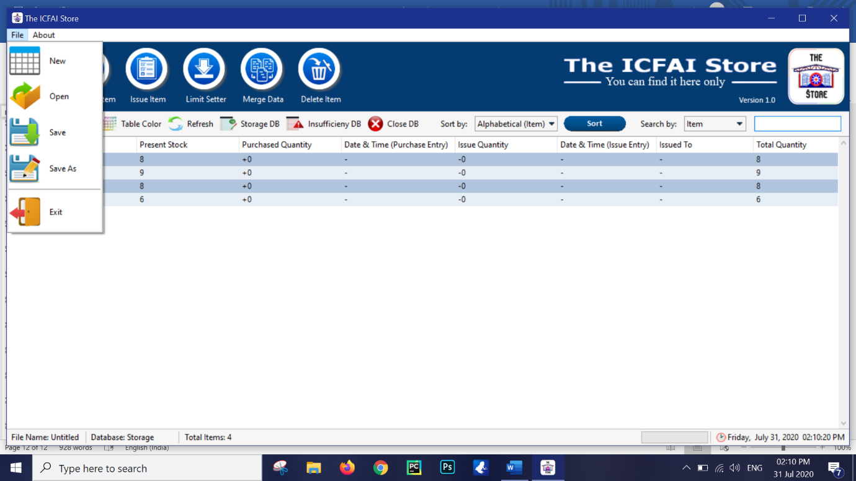

Pressing the File -> New Database will open a blank database with the intro inactive screen



Point to observe

* The new database will be untitled again

The rest are self explanatory.

Hope this document helps.

Thank you for using The ICFAI Store